Basic Stationery Requirements for Year 2023

Children must arrive at school on the first day with the following basic items:

- 2 pencils
- 2 blue biros
- 1 red biro
- 2 black biros
- 1 30 cm ruler – rigid plastic only (no steel or bendy rulers)
- 1 eraser
- 1 pair scissors
- 1 set coloured pencils – 12 or more preferable
- 1 glue stick
- 3 different coloured highlighters
- 1 whiteboard pen
- 6 1B5 exercise books
- 2 1E5 Quad books
- 1 14B5 lined pad
- 3 A4 clearfile - 20 pockets (2 for Technology classes)
- 2 Reams A4 photocopy paper

1 school diary – to be issued by the classroom teacher during the first week of school. Price to be notified.

Class teachers may request additional items.

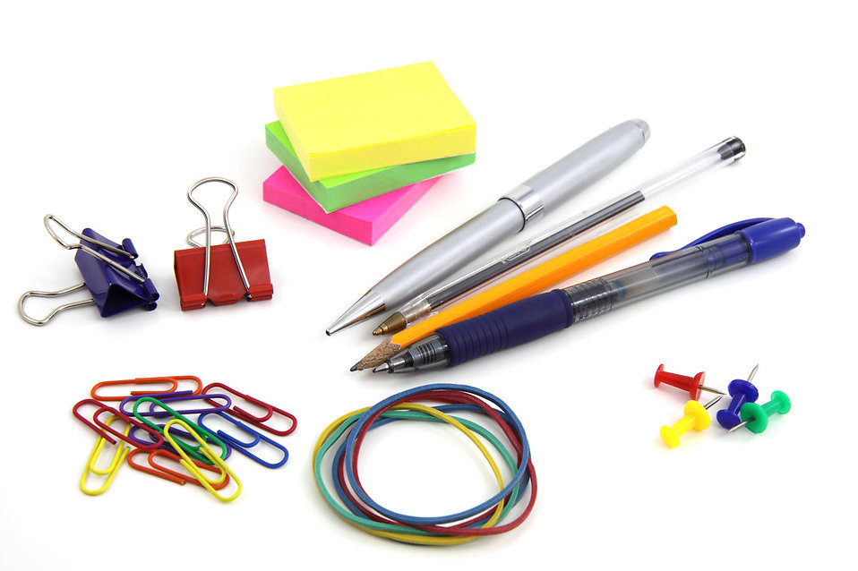
ALL ITEMS TO BE NAMED

