MANA

This is the school’s system for teaching positive behaviour for learning.

The MANA Values:
Respect – Being caring and considerate
Diligence – Achieve your personal best
Integrity – Be honest and trustworthy
Service – Help and be actively involved

The MANA system rewards students displaying positive behaviours. Each day students who show all four MANA values get the tracking sheet in their school diary signed off by the classroom teacher. If they achieve this 80% or more they qualify for the MANA reward days.

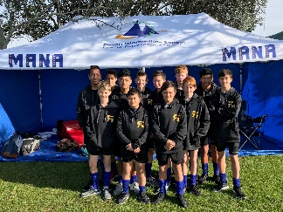
Fortnightly goals are set for the whole school. Expected behaviours are then taught in every class. Students who display the expected behaviours are rewarded with MANA tickets that accumulate and are exchanged for rewards.

Expectations for behaviour are clear and consistent. Inappropriate behaviours have set consequences, and opportunities are provided for students to reflect on and modify their behaviour.
AIMS 2018

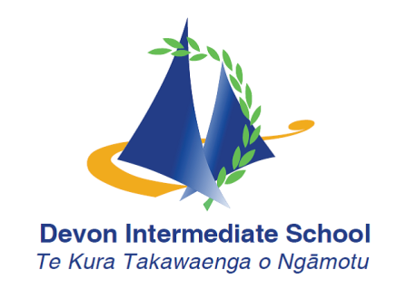
Opportunities

Devon Intermediate offers an amazing array of opportunities for students to try new things, build on their strengths and discover their passion.

The Attitude for Excellence Awards encourages students to participate in Academics, Sports, The Arts and Community Service. As students participate in activities in these areas, they earn points towards their Merit badges. Get all four and you earn your Overall Attitude for Excellence.

There are too many opportunities to list them all but here are some to consider:
- Kapa Haka, Pasifika, Ukulele and Choir as well as a full school production.
- From Surfing to duathlon, basketball to badminton, or rugby to indoor bowls we have a sport for everyone.
- A range of school based monitors and student leadership. SPCA events, office duty, bell monitors etc.
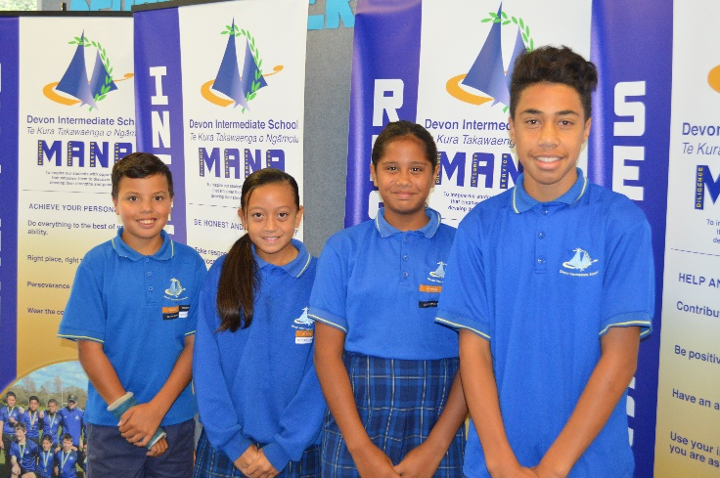
- Challenge yourself with international tests, maths and science fairs, debating and speeches.

Enrichments allow students to select an activity to participate in including yearbook, graduation ball, movie making and future leaders.
Each student at Devon Intermediate also gets to experience and develop hands on skills in Technology in Hard Materials Metal and Wood, Food technology and Digital Technology.

Diligence
Integrity
Service
Respect

Our Mission:

To inspire our students with opportunities for success that empowers them to discover and develop their strengths in a positive learning environment
Achievement

The core business of the school is learning. At Devon Intermediate, we have a proven ability to accelerate learning for our students in both literacy and numeracy and we consistently have students achieving at a very high level.
J Rock
AIMS Games 7’s Team
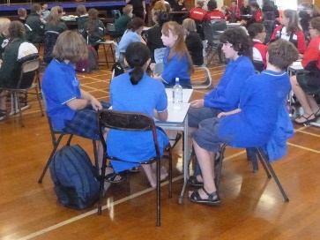
We believe in targeted learning and organise our teaching and learning programmes to meet the needs of the individual learners.
Kid’s Lit Quiz 2018

Prime learning time is a feature of Devon Intermediate with students focused on learning Reading, Writing and Mathematics.

We help set up all students for success by teaching goal setting and organisational skills and we work collaboratively with the whanau during our Pathway and Planning meetings to ensure your child’s education is a partnership between home and school.
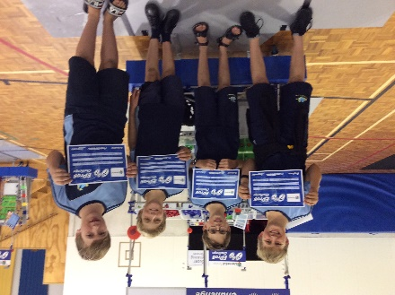

EPRO8 2019
Inclusion

All students that attend Devon Intermediate are treated fairly and with respect. All learners have their individual learning needs catered for in class. Programmes are modified to include all students.

School-wide events like Swimming Sports, Cross Country and Athletics have two levels – Participation and Championships. This allows all students to achieve at their level.
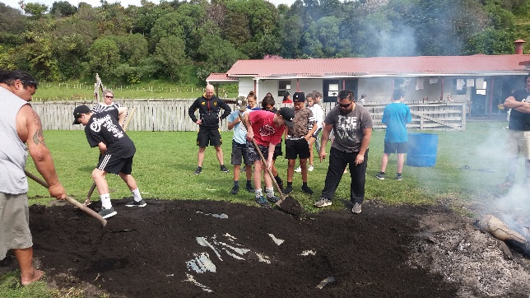
At Devon Intermediate we are proudly culturally diverse and a true representation of the New Zealand and global communities.

Our low class numbers and highly experienced staff allows every student to be challenged and nurtured in their learning. Staff share their passions and experience with the students by offering a wide range of in school and after school activities.
Marae Camp 2018

At Devon Intermediate, all students and families are officially welcomed into the Devon community with a Powhiri on the first day. Our focus is on developing strong links with whanau.

Together, we can make a real difference for all the students of our school.
Support

At Devon Intermediate, we support the learning of all students whether they need extension and enrichment activities, some extra help to support learning in an area or assistance with dyslexia or ESOL.

We provide opportunities for gifted and talented students through our GATE programme and have a range of programmes to assist with special learning needs.

We take great care to transition Year 6 students to their new school by providing opportunities to have enjoyable experiences on site. We meet with your child’s current school to ensure we have as much information about your child, their learning and their passions, prior to them being placed in a class. Pathway and Planning meetings are held prior to the start of the school year so you and your child can meet with the class teacher to set goals and get to know one another before class begins.

We have an open door policy at Devon Intermediate. Our staff are happy to meet or discuss with you ways to improve the learning outcomes for your child.

