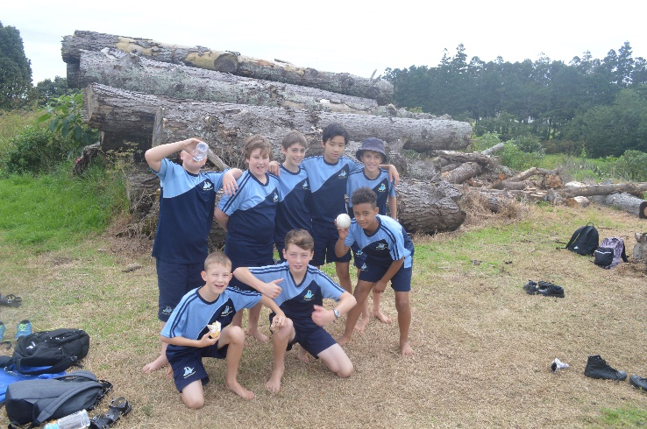

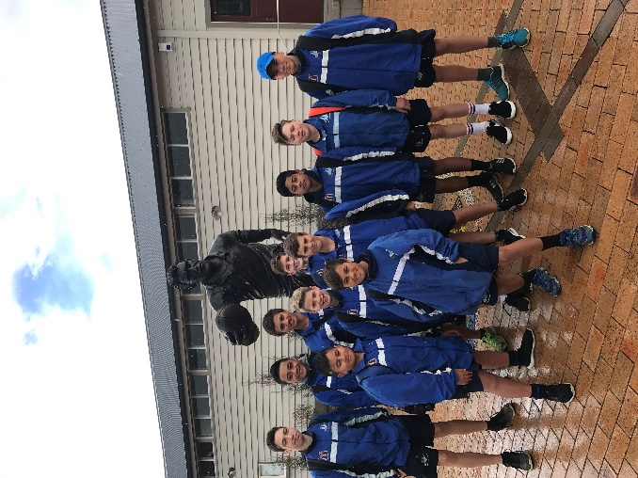
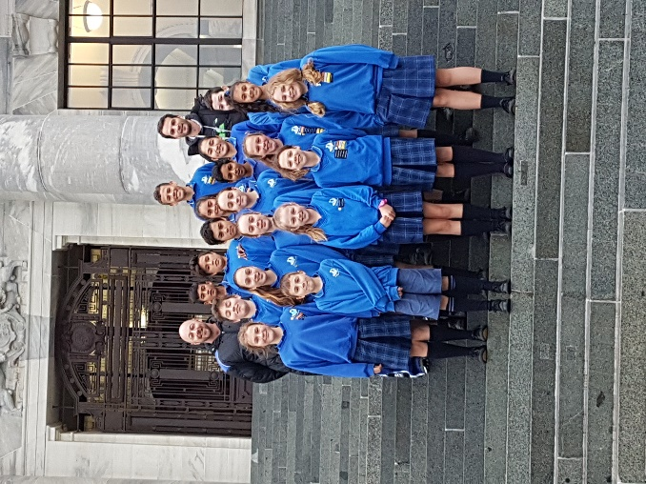
DEVON INTERMEDIATE SCHOOL
CHARTER 2019-2020
DEVON INTERMEDIATE STRATEGIC PLAN 2019-2020

Strategic Goal | Strategic Objectives | 2019 | 2020
1  Student Learning, progress and achievement | 1.1 All students achieve accelerated academic progress as measured by the NZC and standardised assessment tools | - 65 % of students will show accelerated progress in writing as shown by the analysis of E AsTTle writing assessment data  - 40 % of students will show accelerated progress in mathematics as shown by the analysis of PAT Math assessment data  - 65 % of students will show accelerated progress in reading as demonstrated by the use of e AsTTle reading  - All teachers will be involved in intensive Professional Development related to reading and the use and understanding of phonics and Guided Reading  - All teachers will be upskilled in reading assessments, understanding the data and linking it to planning to ensure accelerated progress is made by students.  - Teacher planning will explicitly link to assessment data and show next steps teaching and learning  - Assessment information is understood and used effectively. Moderation of assessment is robust and valid.  - Digital technology tools are used to ensure equity in learning outcomes | - 65% of students will show accelerated progress in writing as shown by the analysis of E AsTTle writing assessment data  - 50% of students will show accelerated progress in mathematics as shown through the analysis of PAT Math assessment data  - 65 % of students will show accelerated progress in reading as demonstrated by the use of e AsTTle reading  - All teachers will be involved in intensive Professional Development related to reading and the use and understanding of phonics and Guided Reading  - All teachers planning and programmes in reading and writing will demonstrate evidence of the use of culturally responsive practices with regard to reading
 | 1.2 Classroom programmes will target students at risk of not achieving accelerated progress as well as Maori boys and we will ensure all are valued and nurtured. | - Sharing of ALL strategies by ALL lead teachers. Phonics programmes are explicitly taught by classroom teachers as required to address barriers to learning.  - Gifted and talented students are targeted with specific programmes.  - All teachers will be involved in intensive Professional Development related to reading and the use and understanding of phonics and Guided Reading  - Procedures with regard to early identification are embedded. | - ALL strategies will be evidenced in planning to address barriers to learning  - All teachers will be involved in intensive Professional Development related to reading and the use and understanding of phonics and Guided Reading and how this can be used to address barriers to learning by at risk students.
 | 1.3 Programmes will ensure Maori students at Devon Intermediate show accelerated progress and the students’ culture and identity is valued. | - Every class will identify target Maori students in reading, who will be tested termly to track progress and ensure appropriate interventions are in place so accelerated progress is made  - Culturally responsive practices and resources will be used in all classes and evidenced in planning and differentiation.  - To ensure accelerated learning, our students will be supported in learning and understanding their cultural history and where they stand in the world | - Tracking of target group students will be the norm and evidenced in planning and reporting by teachers.  - Culturally responsive practices and resources will be used in all classes and evidenced in planning and differentiation.  - To ensure accelerated learning, our students will be supported in learning and understanding their cultural history and where they stand in the world
 | 1.4 Pasifika students at Devon Intermediate show accelerated progress and the students’ culture and identity is valued. | - Culturally responsive practices and resources will be used in all classes and evidenced in planning  - Every class will identify target Pasifika students in reading, who will be tested termly to track progress and ensure appropriate interventions are in place so accelerated progress is made  - Pasifika students will have opportunities to celebrate and participate in their own cultural activities | - Students respective cultures will be valued and culturally responsive practices and resources will be used in all classes and evidenced in planning  - Tracking of target group students will be the norm and evidenced in planning and reporting by teachers

Strategic Goal | Strategic Objectives | 2019 | 2020
2  Effective Teaching | 2.1 Improved teaching and learning for all learners | - Wide use of various teaching strategies will link directly with appraisal as will the direct use of data to inform practice.  - Improvement in progress is evident curriculum wide with a special emphasis on the continuation of writing and a focus on reading  - The use of culturally responsive practices will be evident in all classes and be evidenced in appraisal documents.  - At risk students will be tracked and interventions will be in place in a timely manner using the resources within the school  - Teachers will work collegially, sharing best practice and mentoring each other depending on their individual strengths  - The achievements of all staff are recognised and celebrated regularly | - Wide use of various teaching strategies will link directly with appraisal as will the direct use of data to inform practice.  - Improvement in progress is evident curriculum wide with a special emphasis on reading  - Culturally responsive practices will be the norm at Devon Intermediate  - Teachers will work collegially, sharing best practice and mentoring each other depending on their individual strengths  - The achievements of all staff are recognised and celebrated regularly
 | 2.2 Teaching will be evidence based and collaborative | - Tracking of student achievement and progress will be an embedded practice and explicitly define next step learning needs of at risk students  - Team unit planning and moderation is collaborative and based on mutual trust and respect  - Resource bank for all curriculum levels will be available on Teacher write  - Moderation is an embedded practice in team meetings  - Units are collaboratively planned and implemented and made available on Teacher write for staff use | - Tracking of student achievement and progress will be an embedded practice and explicitly define next step learning needs of at risk students  - Resource bank for all curriculum levels will be available on Teacher write and added to by teams as planning is completed  - Moderation is robust and a norm for assessment marking and analysis of results
 | 2.3 Teaching staff will take part in targeted professional development aimed at upskilling their teaching practice and ensuring high level student engagement. | - All staff will take part in the Reading professional development and use the strategies and resources developed in the PD as part of their classroom practices. | - All staff will continue to take part in the Reading professional development and use the strategies and resources developed in the PD as part of their classroom practices
 | 2.4 Appraisal goals will link to school strategic goals and will be evidence based. | - Appraisal will be an embedded practice  - Appraisal documentation will be consistent across the whole school and used to empower and improve teaching and learning | - Appraisal will be an embedded practice  - Appraisal documentation will be consistent across the whole school and used to empower and improve teaching and learning

Strategic Goal | Strategic Objectives | 2019 | 2020
3  School Culture | 3.1 Provide opportunities for all students to develop and celebrate success in areas of culture, sports, academics and the arts | - Tier 1,2 and 3 will be embedded in school culture  - There will be consistency across the whole school with regard to the application of the MANA programme  - Enrichment programmes will provide a wide range of opportunities for students to explore their passions. Community groups will be encouraged to provide programmes which support the ethos and aims of the school  - The Attitude for Excellence programme will be reviewed and expanded depending on the review outcomes.  - The school will explore ways of ensuring barriers to opportunities, i.e. costs, are removed to ensure all students can access the opportunities offered.  - Provide a wide range of sporting opportunities including Friday sports, interschool sports exchanges, swimming/ athletics and cross country events.  - Provide a wide range of opportunities to be involved in the Arts including Kapa haka, Pasifika, Production, art exhibition, speech competitions etc.  - Partnerships with local community organisations will be formed to ensure a wide range of opportunities are offered to the students | - Tier 1,2 and 3 will be BAU within the school  - There will be consistency across the whole school with regard to the application of the MANA programme  - Enrichment programmes will provide a wide range of opportunities for students to explore their passions. Community groups will be encouraged to provide programmes which support the ethos and aims of the school  - The school will explore ways of ensuring barriers to opportunities, i.e. costs, are removed to ensure all students can access the opportunities offered  - Provide a wide range of sporting opportunities including Friday sports, interschool sports exchanges, swimming/ athletics and cross country events.  - Provide a wide range of opportunities to be involved in the Arts including Kapa haka, Pasifika, Production, art exhibition, speech competitions etc.  - Partnerships with local community organisations will be further developed to ensure a wide range of opportunities are offered to the students
 | 3.2 Provide an inclusive and nurturing environment where difference and diversity is celebrated. | - Celebrate student achievement with awards and recognition within classes, team and school assemblies as well as public acknowledgement on Facebook page, newsletters etc.  - Further develop links with outside organisations, e.g. MOST FM to allow our students access to celebrate the school’s achievements and events on radio  - All students will be able to access the opportunities offered at Devon Intermediate either in a supported or non-supported way.  - Those with special education needs will be offered opportunities to enhance their education, e.g. Riding for the Disabled, Movables etc.  - Staff receive professional development to assist them with understanding learning and behavioural needs and are provided with strategies to assist them with their teaching of students with needs  - Staff continue to receive cultural awareness training and correct tikanga protocols are BaU in the school and classroom. | - Celebrate student achievement with awards and recognition within classes, team and school assemblies as well as public acknowledgement on Facebook page, newsletters etc.  - All students will be able to access the opportunities offered at Devon Intermediate either in a supported or non-supported way.  - Those with special education needs will be offered opportunities to enhance their education, e.g. Riding for the Disabled, Movables etc.

Strategic Goal | Strategic Objectives | 2019 | 2020
4  Engaging Families | 4.1 Provide a wide range of opportunities for whanau to engage with the school | - Refine and embed pathways and planning meetings to ensure goal setting and reporting to parents is robust and a valuable tool for the student and whanau  - 80% of whanau attend Pathway and Planning meetings  - Whanau are included in the school wide Reading professional development and are upskilled in how to teach reading  - Whanau are encouraged to join in school celebrations, hui and events  - The Community Liaison position is refined and embedded in school culture and is an integral and valued link between home and school  - At least one Ngati te Whiti representative is part of the Board of Trustees | - Refine and embed pathways and planning meetings to ensure goal setting and reporting to parents is robust and a valuable tool for the student and whanau  - 85% of whanau attend Pathway and Planning meetings  - Whanau are included in school wide professional development where appropriate  - Whanau are encouraged to join in school celebrations, hui and events

Strategic Goal | Strategic Objectives | 2019 | 2020
5  Leadership and Management | 5.1 Strong leadership team whose sole purpose is to support and guide improved teaching and learning for all learners at Devon Intermediate | - Leadership team are reflective practioners who have a focus on improved practice across the whole school  - Support is provided in the timely manner to those who need it be it professionally or personally  - Robust discussion is encouraged  - Leadership team are empowered to make the tough decisions and are supportive of each other and the staff.  - Professional development is encouraged and professional readings/ videos etc. are part of the leadership team meetings  - Review of school procedures and processes is seen as vital to school improvement  - Appraisal across the school is consistent and led by the leadership team  - Modelling and mentoring is embedded | - Leadership team are reflective practioners who have a focus on improved practice across the whole school  - Leadership team are empowered to make the tough decisions and are supportive of each other and the staff.  - Skills matrix is completed to assess strengths and needs of the leadership team  - Professional development is encouraged and professional readings/ videos etc. are part of the leadership team meetings  - Appraisal across the school is consistent and led by the leadership team  - Modelling and mentoring is embedded and led by the leadership team
 | 5.2 Provide opportunities for the senior and middle leadership teams’ development. | - Skills matrix is completed and professional development needs assessed. Leadership programme is developed and introduced  - Leadership opportunities are shared as and where possible to develop all staff | - Skills matrix is completed and professional development needs assessed. Leadership programme is developed and introduced  - New leaders are developed using opportunities within the school  - Leadership opportunities are shared as and where possible to develop all staff

Strategic Goal | Strategic Objectives | 2019 | 2020
6  Governance | 6.1 Monitor and evaluate student learning outcomes | - Board members have a thorough understanding of what assessment tools are bring used and what assessment information means  - Board members are reported to at start, middle and end of year with regard to academic progress and have a thorough understanding of the data  - Board members are cognisant of resourcing required to ensure positive learning outcomes for all students at Devon Intermediate. | - Board members have a thorough understanding of what assessment tools are bring used and what assessment information means  - Board members have a thorough understanding of what assessment tools are bring used and what assessment information means  - Board members are cognisant of resourcing required to ensure positive learning outcomes for all students at Devon Intermediate.
 | 6.2 Exercise governance in a way which fully embraces the intent of Te Tiriti o Waitangi by valuing and reflecting New Zealand’s bicultural partnership | - Te Tiriti o Waitangi underpins and guides all decisions by the board with regard to Devon Intermediate | - Te Tiriti o Waitangi underpins and guides all decisions by the board with regard to Devon Intermediate
 | 6.3 All legislative requirements will be adhered to and completed | - The Board ensure all that all legislative requirements and adhered to and completed in a timely manner | - The Board ensure all that all legislative requirements and adhered to and completed in a timely manner
 | 6.4 To ensure a financial secure school which is resourced appropriately. | - The Board approves and monitors the budget to ensure the school is fiscally sound and resources are appropriately spent to ensure the strategic objectives of the school are met. | - The Board approves and monitors the budget to ensure the school is fiscally sound and resources are appropriately spent to ensure the strategic objectives of the school are met.

Annual Plan

Strategic Goal | Strategic Objectives | 2019 Actions | Budget | Timeframe | Personnel Responsible
1  Student Learning and Progress | 1.1 All students achieve academic success as measured by the NZC and standardised tests such as E AsTTle and PAT | - School assessment is recorded on KAMAR and used to inform next step learning.  - School wide assessment is relevant, understood and rigorously moderated within teams and across school  - Academic success is triangulated using formative assessment, summative assessment  - Currently 29% of our year 7 students ended the 2018 year at a 'critical' (less than expected curriculum level) for reading. We aim to drop this to 15% by the end of 2019  - 60% of our Year 7 and 8 students will make accelerate progress in reading as staff increase their knowledge and skill set with regards to phonics and guided reading  - 75% of our students will make accelerated progress in writing. This will be measured using e AsTTle and accelerated progress would be shown by two or more sub-level improvement.  - Target students (35% of year 7 and 8’s) in maths will make accelerated progress as measured by an increase of 5.5 or more in the scaled PAT Maths score  - Co planning and co teaching is used across the school by all staff to support the PDLP being implemented by Dr Davis and Vision Education |  | - Ongoing throughout the year  - Termly  - Termly  - Ongoing throughout the year  - Ongoing throughout the year  - Ongoing throughout the year | SLT/ Board/ Team leaders/Staff
 | 1.2 Classroom programmes will target students at risk of not achieving and special needs students and will ensure all are valued and nurtured. | - At risk and gifted students will be identified through data analysis by Teams  - The Tier 2 PB4L team will work collaboratively with classroom teachers to co-construct and implement differentiated programmes that support at risk students  - Target and priority students will be tracked by class teachers and Team leaders to ensure accelerated progress is occurring in at least one curriculum area.  - Staff will increase their knowledge and understanding of ASD, FASD and Dyslexia, with strategies and ideas being shared to support the students learning  - ALL lead teachers share knowledge and upskill staff  - Unit and class planning will demonstrate differentiation and scaffolding of skills  - At risk and GaTE programmes will be reviewed and redeveloped as necessary |  | - Term 1  - Termly  - Term 1/2  - Ongoing throughout the year  - Ongoing throughout the year  - Term 1/2 | SENCO/ SLT/ Team Leaders/ Whole staff
 | 1.3 Programmes will ensure Maori students at Devon Intermediate show accelerated progress and the students’ culture and identity is valued. | - Unpack Ta Taiako to ensure school wide understanding of concepts and required actions.  - Unit plans will reflect an increased focus on ensuring students understand ‘where they stand’  - Target group are tracked and interventions are in place to ensure academic progress  - Community engagement is sought to support and enhance classroom programmes  - Te Tiriti o Waitangi underpins all planning and classroom teaching |  | - Term 1/2 | SLT/ Team leaders
 | 1.4 Pasifika students at Devon Intermediate show accelerated progress and the students’ culture and identity is valued | - Develop classroom teaching units which value Pacifica culture  - Provide access to all those who wish to belong to the Devon Intermediate Pacifica group  - Community engagement is sought to support and enhance classroom programmes |  | - Ongoing throughout the year | SLT/ Team leaders

Strategic Goal | Strategic Objectives | 2019 Actions | Budget | Timeframe | Personnel Responsible
2  Effective Teaching | 2.1 Improved teaching and learning for all learners | - Units and school wide overview is stored on teacher write for all to access  - All staff will be fully and actively involved in PDLP as per the PDLP plan with Dr Davis and team with regards to reading  - A focused PD plan is actively engaging all staff and their improved skills set and knowledge base is being transferred in to the classroom as evidenced by the appraisal system.  - All staff and students will complete the wellness survey to ensure any needs are met so that teaching and learning can occur |  | - Term 1  - Ongoing throughout the year | SLT  Literacy lead team
 | 2.2 Teaching will be evidence based and collaborative | - 2 year assessment plan is developed and followed  - Unpack and upskill staff in the use Guided Reading and Phonics  - Whole staff moderation of work and assessment is completed termly  - Unit plans will be shared on Teacher Write  - Teams will collaboratively plan and implement integrated programmes  - Two year teaching cycle is developed with unit plans being collaboratively written  - Co planning will occur to ensure improved teaching practice and involvement will be linked to appraisal expectations  - Classrooms teachers complete self-assessment using the PB4L CAT tool  - PB4L Tier 1 and 2 leaders use the CAT tool to support teachers to identify inquiry focus areas  - PB4L Tier 1 and 2 team will collate the CAT and SET walk through tool data to identify school wide trends for further Professional Development |  | - Term 1  - Term 1  - Term 1  - Termly  - Ongoing throughout the year  - Ongoing throughout the year  - Ongoing throughout the year | All staff
 | 2.3 Teaching staff will take part in targeted professional development aimed at upskilling their teaching practice and ensuring high level student engagement | - All staff will be fully and actively involved in PDLP as per the PDLP plan with Dr Davis and Vision Education with regards to reading |  | - Ongoing throughout the year | All staff
 | 2.4 Appraisal goals will link to school strategic goals related to reading and PB4L and will be evidence based. | - Teacher inquiry will reflect the school PD focus of reading  - PB4L CAT tool data will inform next step classroom management practices with regard to restorative conversations and practices |  | - Ongoing throughout the year  - Ongoing throughout the year | All staff

Strategic Goal | Strategic Objectives | 2019 Actions | Budget | Timeframe | Personnel Responsible
3  School Culture | 3.1 Provide opportunities for all students to develop and celebrate success in areas of culture, sports, academics and the arts | - Promote and celebrate the MANA values and goals school wide through consistent implementation of The MANA Way (PB4L Best Practice)  - Celebrate student achievement regularly with awards in class, across teams, and school wide  - Increase the number of opportunities for students to achieve academically within class programmes and such events as Literary Challenge, ICAS, Otago maths etc.  - Provide a wide range of sporting and cultural events and opportunities by inviting community members to share their expertise  - Celebrate overall achievement in academics, sports and arts at the end of year prize giving assemblies |  | - All ongoing | SLT/ whole staff
 | 3.2 Provide an inclusive and nurturing environment where difference and diversity is celebrated | - PB4L is consistently applied across the whole school  - Tier 2 team is proactive and solutions focused  - Opportunities are made available to all students with any barriers being removed to ensure positive experiences |  |  | MANA team/ SLT/ Whole staff

Strategic Goal | Strategic Objectives | 2019 Actions | Budget | Timeframe | Personnel Responsible
4  Engaging Families | 4.1 Provide a wide range of opportunities for whanau to engage with the school | - Pathways and planning meetings will be held prior to the start of term 1 and during term 2  - Regular sporting events such as swimming sports athletics sports, cross country, Kapa Haka and Pacifica performances will be held  - Whanau are invited to share in the professional development with regards to reading. The aim is 5 whanau per class are involved.  - Ensure continued funding for the community liaison position  - Team newsletters are sent home once a term from each teacher |  | - Ongoing | SLT

Strategic Goal | Strategic Objectives | 2019 Actions | Budget | Timeframe | Personnel Responsible
5  Leadership and Management | 5.1 Strong leadership team whose sole purpose is to support and guide improved teaching and learning for all learners at Devon Intermediate | - Principal and SLT members to upskill Team leadership collation and use of analysis to improve teaching practice  - SLT work collaboratively to strategically improve teaching and learning as well as school culture  - SLT are involved in personal professional development to ensure they are leaders of learning. |  | - Ongoing throughout the year | Principal
 | 5.2 Provide opportunities for the senior and middle leadership teams’ development. | - Professional readings and discussions are included at all Leadership Team meetings  - Leadership team identify learning needs as a group.  - Skills matrix is developed and used to assess leadership skills strengths and needs |  | - Ongoing throughout the year | Principal/ SLT members

Strategic Goal | Strategic Objectives | 2019 Actions | Budget | Timeframe | Personnel Responsible
6  Governance | 6.1 Monitor and evaluate student learning outcomes | - Baseline achievement data is provided to the Board during term one and then monitored termly  - National norms are provided as a comparative for Devon Intermediate comparisons.  - Evaluate regular reports from the Principal on progress of target students toward their goals and assist teachers, if necessary, with resourcing initiatives for improvement. |  | - Termly | Principal/ Board
 | 6.2 Exercise governance in a way which fully embraces the intent of Te Tiriti o Waitangi by valuing and reflecting New Zealand’s bicultural partnership | - Te Tiriti o Waitangi underpins decision making by the Board with regard to governance practices  - Ensure all BOT members understand the obligations outlined in Te Tiriti o Waitangi and undertake professional development opportunities as the need arises. |  | - Ongoing throughout the year | Principal/ Cultural adviser/ Board
 | 6.3 All legislative requirements will be adhered to and completed | - All legislative requirements are known to the Board through the Principals report and are signed off in a timely manner.  - The Board are informed of any legislative changes through the Principals report. |  | - Ongoing throughout the year | Principal/ Board
 | 6.4 To ensure a financial secure school which is resourced appropriately. | - The BoT make strategic decisions which ensure the school is fiscally sound.  - A board member with financial skills is actively sought to join the board |  | - Ongoing throughout the year | Principal/ Board

