***The Devon Intermediate School Uniform***

Devon Intermediate has an attractive and functional uniform. We are proud of it and expect it to be worn correctly. The uniform is available from Campus Clothing, 94 Gill Street, New Plymouth.

***Definitions***

**Summer** Terms 1 and Term 4

**Winter** Terms 2 and Term 3

***Summer***

* Navy drill shorts. Additional options for girls – blue and yellow tartan wool polyester skirt or culottes.
* Royal blue polo knit shirt with school logo and lemon pinstripe on collar and sleeve (short sleeved).
* Royal blue V-neck sweatshirt with school logo.
* Black Roman sandals, black Gladiator sandals or black flat sole sandals with a heel strap.
* School navy, wide-brimmed or bucket hats – available from the school office.

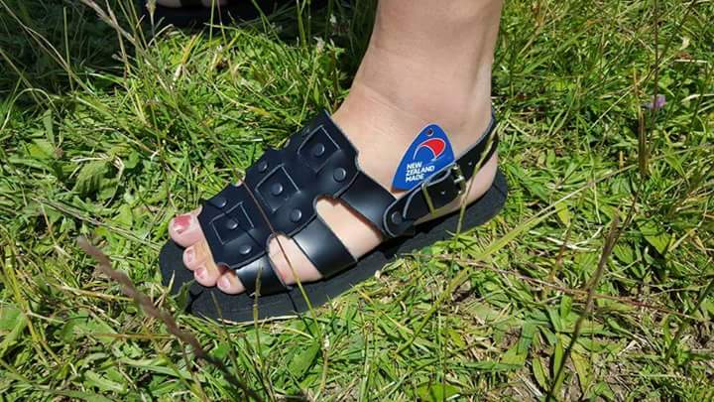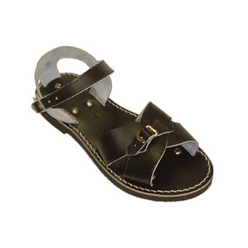



***Winter***

* Navy drill shorts. Additional options for girls – blue and yellow tartan wool polyester skirt or culottes.
* Royal blue polo knit shirt with school logo and lemon pinstripe on collar and sleeve.
* Royal blue V-neck sweatshirt with school logo.
* Flat black polishable school shoes only, either lace-up, buckled or velcroed (no colour brank markings, slip-ons or canvas shoes).
* Devon uniform socks or navy blue socks – ankle or knee length.
* Official Taslon Devon jacket (optional).
* 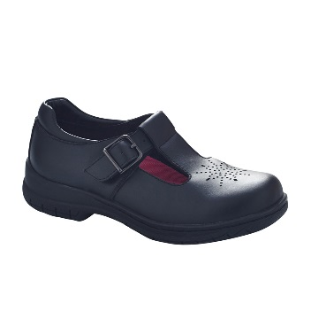Official Taslon Devon tracksuit pants (optional).

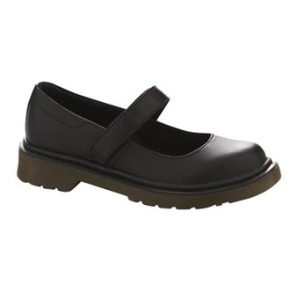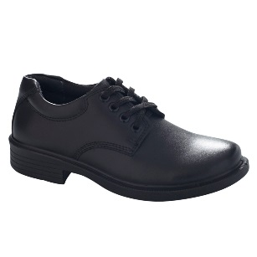

***Physical Education Uniform***

* Quickdry 2-tone blue sports shirt
* Quickdry blue sports shorts

***Hair Ties***

* Only plain royal blue, white or black hair ties are to be worn.

***Jewellery***

* For safety reasons it is inappropriate for jewellery to be worn to school. The only exceptions are:

1. A wristwatch
2. Small stud earrings – no more than one stud in each ear. Sleepers are not to be worn, nor any other visible body piercing.

***Note:***

* We recommend dark navy thermal, short sleeve tops to be worn under polo shirts for extra warmth. It is not acceptable to wear t-shirts or halter-neck tops. These items will have to be removed.
* Shoes are not be worn in the summer terms, sandals are not be worn in the winter terms.
* Official Devon school jackets can be worn to and from school, in the playground, but not in class. Alternative rain jackets can be worn to and from school but should be a neutral colour – blue or black.